

Lab Journal: Open-Ended
Date: 10/18/2025

Student : Lotfullah Muslimwal
Enrollment : 01-131232-039

Department of Software Engineering

Bahria University, Islamabad

Software Construction-Lab (Fall-2025)
Teacher: ENGR. SAAD MAZHAR

Task No: | Task Wise Marks |  | Documentation Marks |  | Total Marks  (20)
Task No: | Assigned | Obtained | Assigned | Obtained | Total Marks  (20)
1 | 3 |  | 5
2 | 3 |  | 5
3 | 3 |  | 5
4 | 3 |  | 5
5 | 3 |  | 5

Comments:

Signature

Lab 06 – Open Ended

GitHub Repo: Open Ended Code

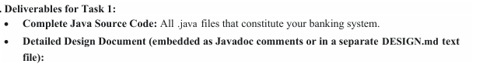

Code for Task 1
Task 1 Code

Screenshot
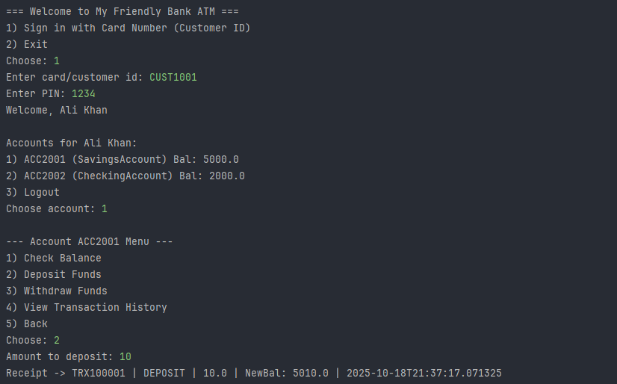

UML Class Diagram for the Task 1
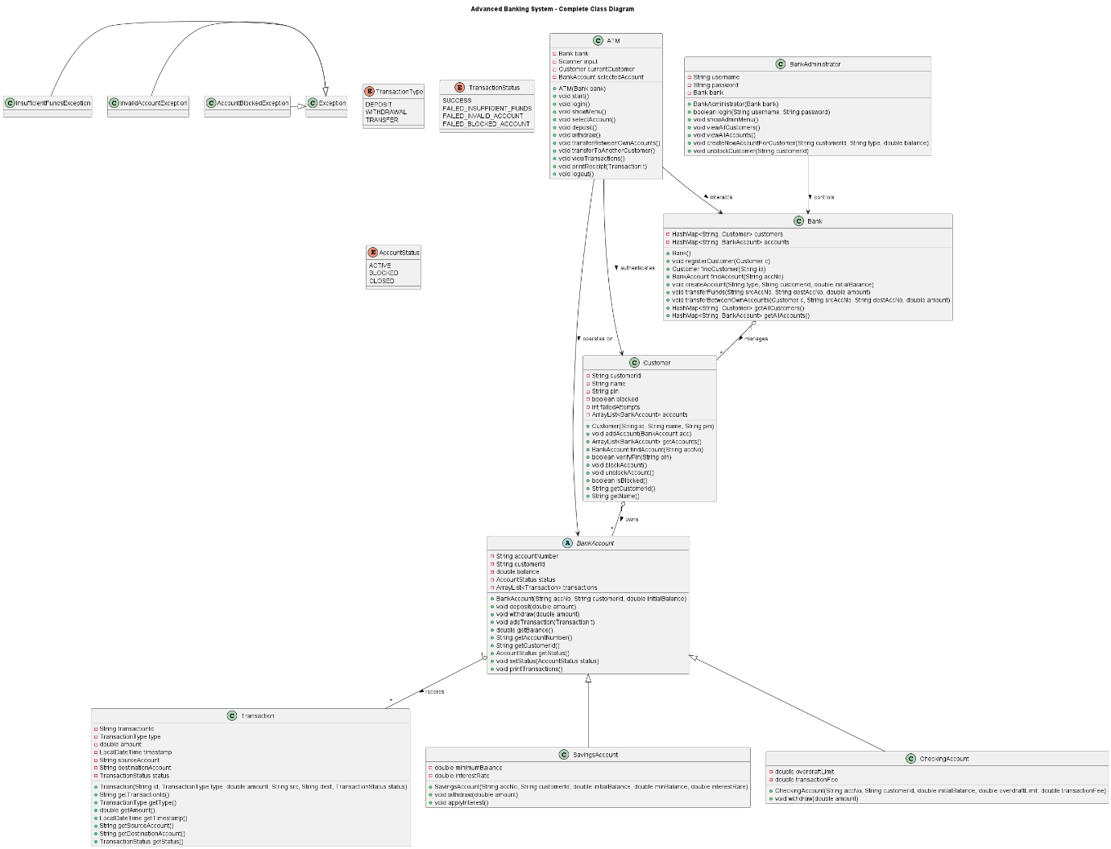

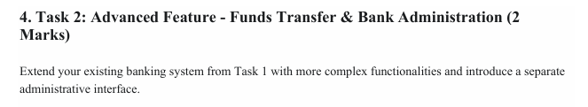
Code for Task 2
Code for Task 2
Screendshot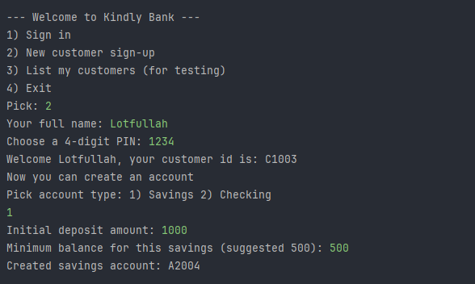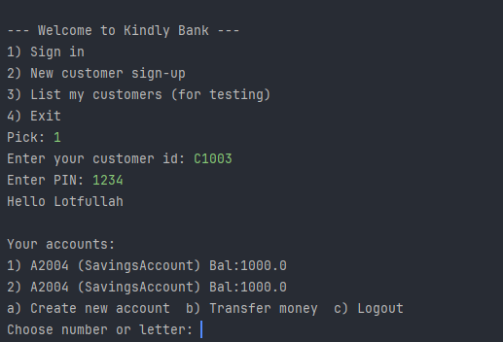
The main difference between Task 2 and Task 1 is that Task 2 adds more user-friendly and complete banking features that weren’t in Task 1.
In Task 1, the ATM only lets existing customers log in and manage their accounts (check balance, deposit, withdraw, view history). There’s no way to sign up as a new customer or create new accounts after the sample data is loaded. Also, money transfers between accounts are not supported.
In Task 2, the ATM is more complete:
- Users can sign up as new customers with their name and PIN.
- After signing in, they can create new savings or checking accounts.
- They can also transfer money between any two accounts (even to someone else’s account, as long as they know the account number).
- The system automatically generates customer and account IDs instead of using fixed ones.
- There’s even a testing option to list all customers.
So, Task 2 is a more realistic and fully functional ATM system, while Task 1 is a simpler version focused only on basic operations for pre-loaded users.

Conclusion

In conclusion, Task 2 significantly improves upon Task 1 by transforming the ATM system from a basic demonstration into a more practical and user-friendly banking application. While Task 1 focuses only on core account operations for pre-registered customers, Task 2 introduces essential real-world features such as customer registration, on-demand account creation, and fund transfers between accounts. These additions make the system more complete, flexible, and closer to how actual banking software operates—allowing users to join, manage multiple accounts, and move money securely. Overall, Task 2 demonstrates a stronger understanding of both user needs and object-oriented design in a realistic software context.

